**Class:** Final Year (Computer Science and Engineering)

**Year:** 2024-25 **Semester:** 1

**Course:** High Performance Computing Lab

## Practical No.8

**PRN No :** 21510036

**Name :** Tushar Rathod

# **Q1: Implement a MPI program to give an example of Deadlock.**

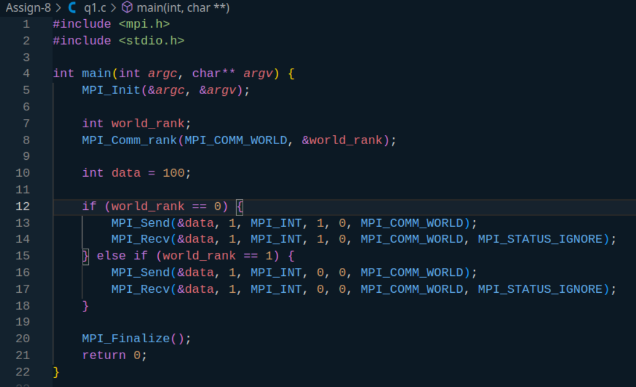

* Process 0 sends a message to Process 1, but it doesn't call MPI_Recv until after the send is complete.
* Process 1 does the same: it sends a message to Process 0, and only after the send completes does it try to receive.
* Both processes are stuck waiting for each other to receive, causing a deadlock.

# **Q2. Implement blocking MPI send & receive to demonstrate Nearest neighbor exchange of data in a ring topology.**

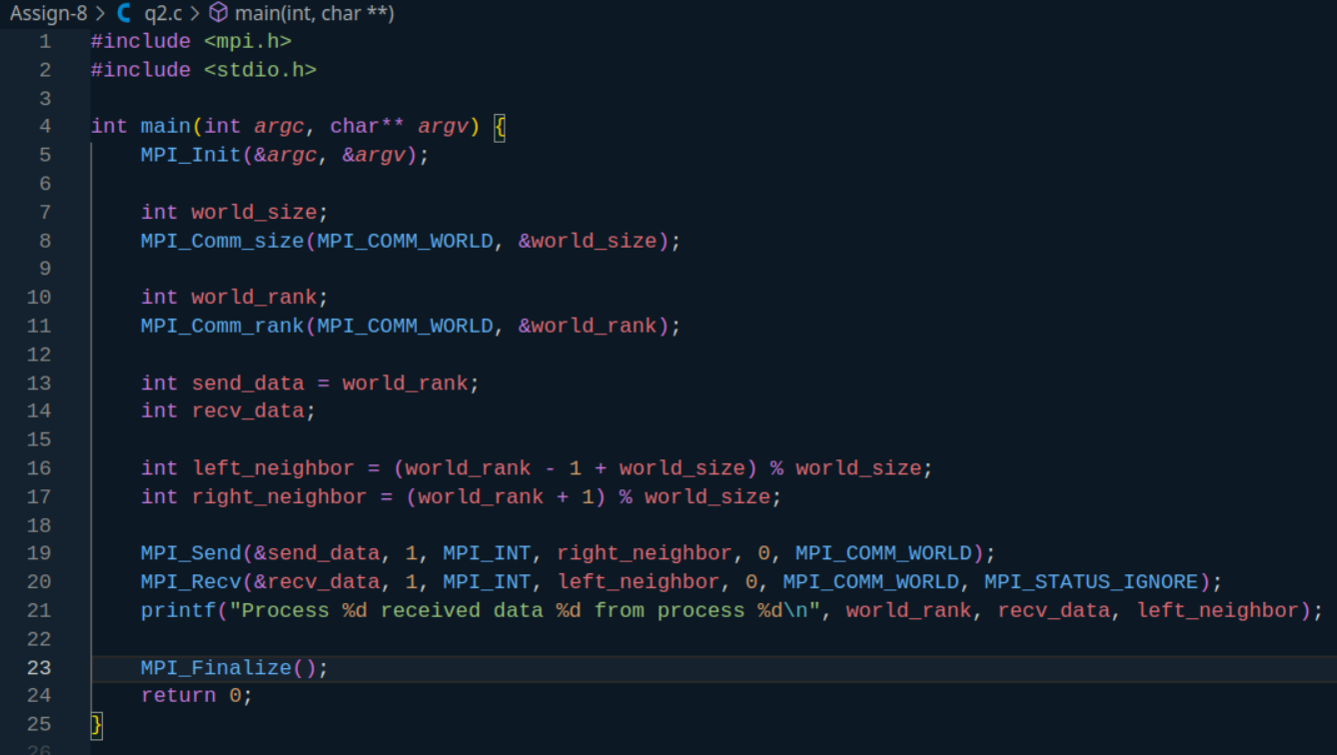

Output -

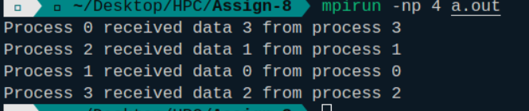

# **Q3. Write a MPI program to find the sum of all the elements of an array A of size**

**n. Elements of an array can be divided into two equals groups. The first [n/2]**

# **elements are added by the first process, P0, and last [n/2] elements the by second process, P1. The two sums then are added to get the final result.**

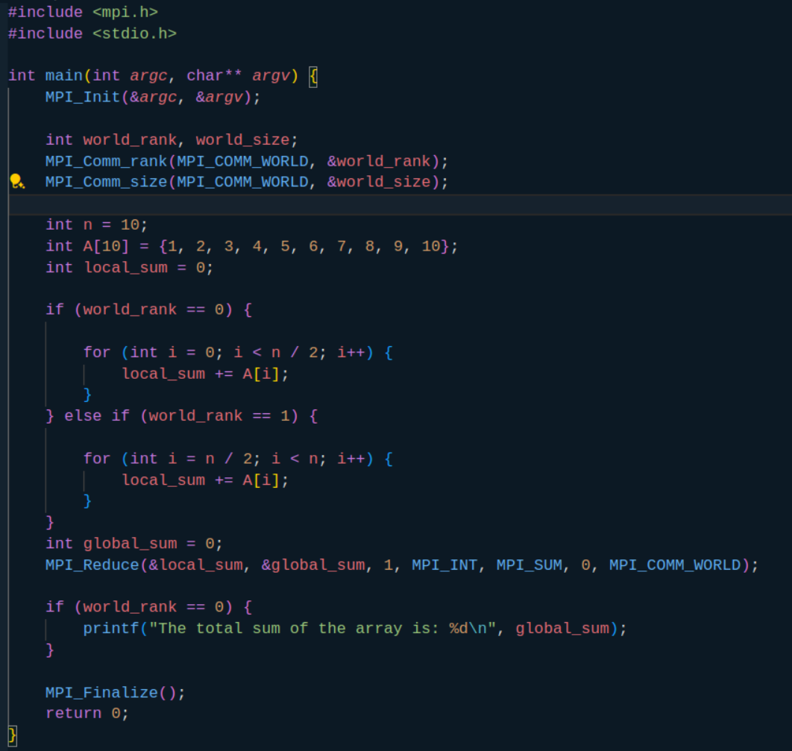

Output -

